

Vision & Scope

ArtBrowser

www.gearedapp.co.uk

Bright Red Ventures

10 Colinton Road

Edinburgh EH10 5DT

info@gearedapp.co.uk

*The contents of this document are for the review by Art Browser only and are strictly confidential and proprietary to both parties*



# Table of Contents

Table of Contents 2

1. Opportunity 3

Background 3

Target Audience 3

The Problem 3

Vision 4

Monetisation 4

2. The Solution 5

Art Browser Mobile App - Main Features 5

Key User Journeys 6

Art Browser Online dashboard 9

App Wireframes 10

Technological considerations 12

Get in touch 12

1. Opportunity

# Background

Rohit Shetty is looking create a Tinder style shopping app for browsing artworks by hundreds of independent artists and galleries.

To date Rohit has raised some funding in order to develop the minimum viable product of the app, and is looking to attract further investment and interest by launching the app on one platform, with the view to adding more functionality and platforms over time.

# Target Audience

There are 2 main target users for this app:

1. Art lovers
2. Artists/Galleries

# The Problem

The art and gallery market can be difficult for both independent artists and art lovers. Artists struggle to get exposure via art galleries, who can be very selective on what work they display. On the other hand art lovers seek an intuitive way to browse art in a digital age, and prefer to browse art from the comfort of their own homes

# Vision

Art Browser would provide a mobile app for Art lovers to browse through art work from hundreds of artists and art galleries. The app would provide a seamless browsing experience, using the tinder style swipe to like/dislike art. Art lovers can build a collection of art they like and purchase art from the artist/gallery. As well as this, Art lovers can browse through artists and galleries profiles, see their other art work, and follow them to receive updates on exhibitions and events.

Artists and galleries would be able to sign up to become part of Art Browser via an online portal/website, where they could add artworks, send out announcements and view any purchases.

## App Goal:

The Goal of Art Browser is to connect art lovers with Artists and Galleries, and create a new digital art market place. It should also provide a unique art browsing experience for its users.

# Monetisation

By providing a digital market place for artwork, there could be various monetisation opportunities. For example:

1. Commission on sales
2. In-app advertising
3. Freemium model
   1. Art lovers can pay to have access additional features (access to premium members gallery, etc.) in the app and remove ads
   2. Artists and Galleries can subscribe to have their profiles upgraded to access additional features (announcement feature, etc)
4. The Solution

# Art Browser Mobile App - Main Features

The following is a list of the envisioned key features:

1. Home (to be called “Browse” or we can just use an icon instead)
   1. Browse art
   2. Filter/search art
   3. View art details
   4. View artist information
   5. Purchase art
2. My Profile
   1. Collection
   2. Activity/Notifications
   3. Settings
   4. T&C’s
   5. Contact Artbrowser
3. Artists (we can combine both Artists and Galleries in one tab and call it “Partners”)
4. Galleries (we can combine both Artists and Galleries in one tab and call it “Partners”)
5. Trending

# Key User Journeys

Below the key app user journeys are outlined. View the accompanying wireframes on pg10 for further clarification.

## Home tab - Browse art

* User taps the app icon to open the app
* A splash screen displays with the ArtBrowser logo
* Login / register, or tap continue to skip this step
* The user is presented with the home page, which has an image of the art work, including a price (If the price is not available a “Display Only” label should show)
* Tap Like, or swipe right to like an artwork, and it will be added to their collection for future reference
* Tap Dislike, or swipe left to dismiss this image
* Artwork will appear in a random order (or maybe instead of random selection artworks should be selected based on popularity).
* Where possible images should not repeat for a user on the same day. If an image is disliked 3 times by the user it will be blacklisted and not appear for that user again.
* If an item is already in the collection a popup will appear advising the user.

## Home tab – Filter/search art

* The user taps the magnifying glass to open a search box and filter options
* The user can either enter a key word in the search box for example “Portraits below £500” or can filter based on:
  + Price
  + Category – Portraits, Photographs, Prints, etc.
  + Etc.
* The user taps apply button to be taken back to home page, with art work matching their search/filter
* Tap “clear filters” to return to default browsing

## Home tab – View art details

* The user taps on the info button/label to access artwork details
* Within the details page the user can view:
  + Title
  + Description
  + Enlarged version (tap to enlarge)
  + Category/tags
  + Price
  + Link to the artist profile
  + Like/unlike button
  + Share button – should allow users to share the artwork/artist profile on their personal social media accounts
  + Buy now button

## Home tab – View Artist/Gallery information

* The user can tap on the artist/Gallery profile bubble on the home page to open the gallery/artist profile
* An artist profile will contain:
  + Website, phone number and email address (if available)
  + Cover image
  + Profile image
  + Name
  + “follow me” button
  + Degree
  + University
  + Grad Year
  + Artist statement
  + Exhibitions
  + All artworks (tiled images)
* A Gallery profile will contain:
  + Website, phone number and email address (if available)
  + Cover image
  + Profile image
  + Name
  + “follow me” button
  + Opening times
  + About the Gallery
  + Upcoming exhibitions
  + Artwork (tiled images)
* The user can tap (follow me) to receive updates and announcement from the artist

## Home tab – purchase art

* Tap the “buy now” button in item details
* User purchase the item via the chosen payment gateway

## My Profile

* User taps on the “my profile” icon in the top left hand corner to open their profile (RS: instead of putting a link to “My Profile” on the Home/Browse page we can have it stand alone as a separate tab similar to Mallzee)
* Tap on the settings tab to manage their profile and account settings including:
  + Push notifications on/off
  + Profile picture
  + Manage your follows
  + Change account settings
  + Password reminder
  + Upgrade
* Tap on the collection tab to view a tiled list of images they have liked
* Tap on the Activity tab to view:
  + Feed of announcements from the artists and galleries the user has followed, as well as sponsored posts
  + Number of new Artworks
  + User will receive a push notification when they receive an announcement
* The user can view t&c’s and contact details

## Artists tab

* User taps on the artist tab to view a list of all artists available
* An advert appears at the top of the list
* Premium listings are shown first in alphabetical order
* Normal listings then follow in alphabetical order
* The user can tap to view artist information (see artist information in Home)
* Search box on the top to allow users to search for a particular artist from the listing quickly

## Galleries tab (same as artists)

* User taps on the galleries tab to view a list of all Galleries available
* An advert appears at the top of the list
* Premium listings are shown first in alphabetical order
* Normal listings then follow in alphabetical order
* The user can tap to view Gallery information (see artist details in Home)
* Search box on the top to allow users to search for a particular artist from the listing quickly

## Trending tab

* User taps the Trending tab to view most recent trending items
* Each category is listed, with a background image like air bnb
* Tap on a category or can search for specific keywords using the search bar
* All relevant trending items are tiled
* Tap an item to view art details (see “view art details” in Home)

# Art Browser Online dashboard

## Main Features

The following is a list of the envisioned key features:

1. Apply to join Art Browser (the join us button in the app could also redirect to the online dashboard)
2. Manage announcements
3. Manage artwork
4. Manage profile
5. Manage account (subscription and upgrading)
6. Contact ArtBrowser

# App Wireframes

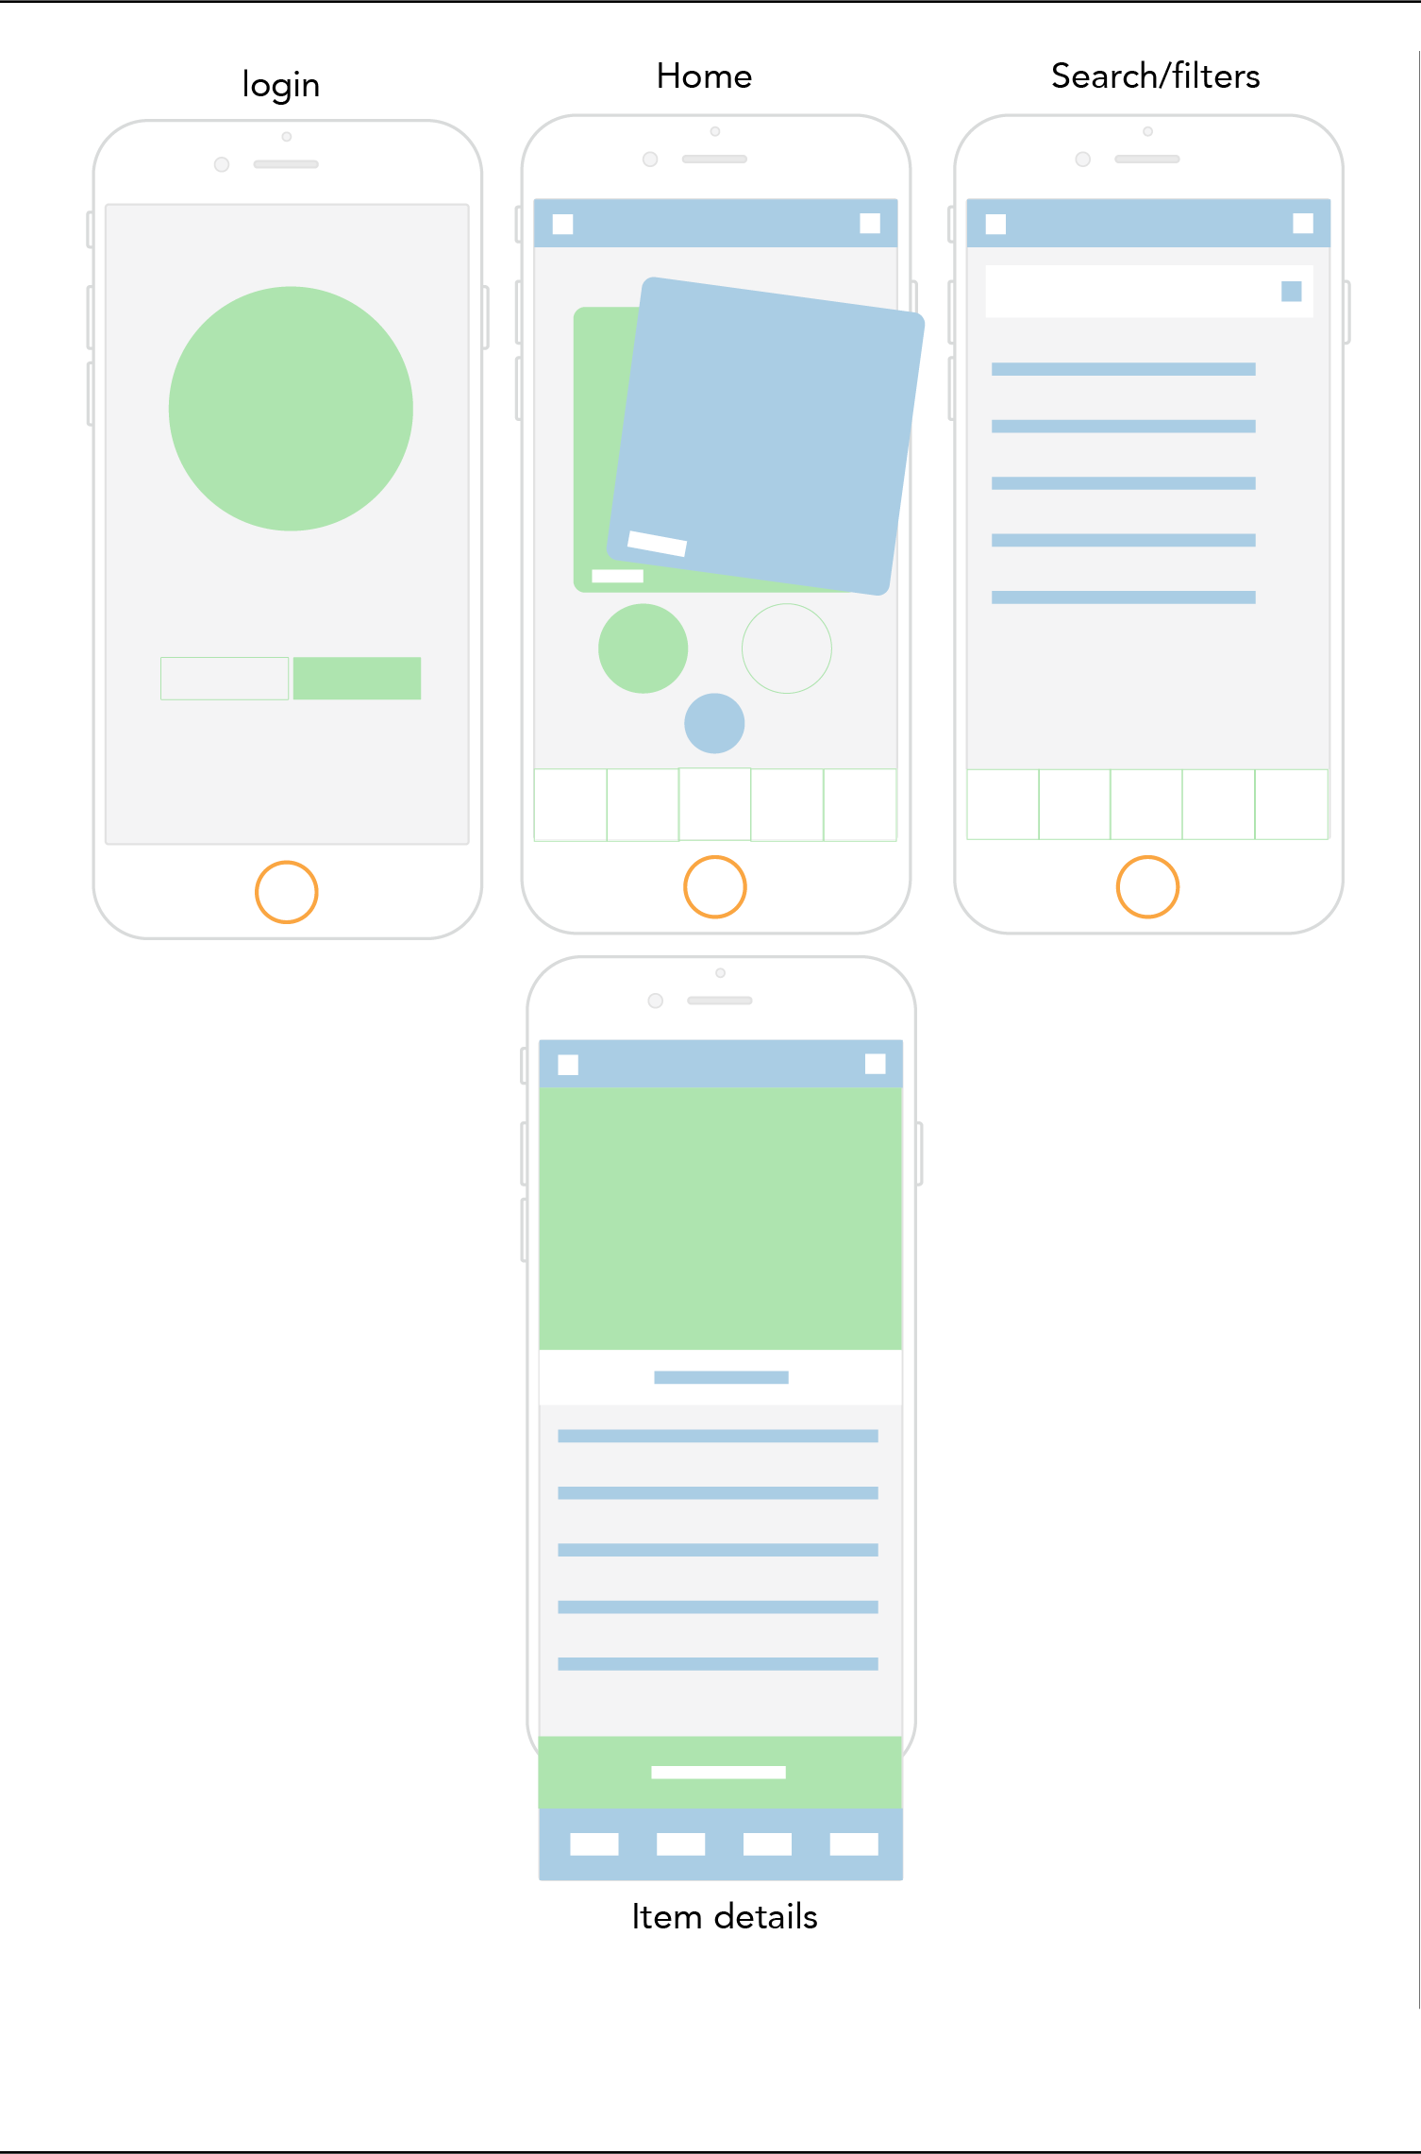

# Macintosh HD:Users:Lara:Desktop:Screen Shot 2015-09-03 at 12.35.45.pngMacintosh HD:Users:Lara:Desktop:Screen Shot 2015-09-03 at 12.35.51.png

# Macintosh HD:Users:Lara:Desktop:Screen Shot 2015-09-03 at 12.35.51.pngTechnological considerations

It is envisioned that iOS operating system will be chosen for the initial version, and that it will be available on apple handheld devices.

Development of an online platform will be required for the artist/art gallery dashboard.

Get in touch

Please don’t hesitate to get in touch if you would like to explore this further. Lara will be available to answer any questions regarding this document.

# Email **lara@gearedapp.co.uk**

# Phone Lara **(+44) 07922742374**

# Check our site **www.gearedapp.co.uk**

# Or visit us **Bright Red Ventures,**

# **10 Colinton Road,**

# **Edinburgh**

# **EH10 5DT**